UNITED STATES
SECURITIES AND EXCHANGE COMMISSION
Washington, DC 20549

FORM 8-K

CURRENT REPORT

PURSUANT TO SECTION 13 OR 15(d) OF THE
SECURITIES EXCHANGE ACT OF 1934

Date of Report (Date of earliest event reported): September 14, 2026
Aquestive Therapeutics, Inc.
(Exact name of Registrant as specified in its charter)
Delaware |  |  | 001-38599 |  |  | 82-3827296
(State or other jurisdiction of incorporation) |  |  | (Commission File Number) |  |  | (I.R.S. Employer Identification No.)

30 Technology Drive
Warren, NJ 07059
(908) 941-1900
(Address, Including Zip Code, and Telephone Number, Including Area Code, of Registrant’s Principal Executive Offices)

Not Applicable
(Former name or former address, if changed since last report)

________________________________________________________________________________________________________________________
Check the appropriate box below if the Form 8-K filing is intended to simultaneously satisfy the filing obligation of the registrant under any of the following provisions:
☐ |  |  | Written communications pursuant to Rule 425 under the Securities Act (17 CFR 230.425)
☐ |  |  | Soliciting material pursuant to Rule 14a-12 under the Exchange Act (17 CFR 240.14a-12)
☐ |  |  | Pre-commencement communications pursuant to Rule 14d-2(b) under the Exchange Act (17 CFR 240.14d-2(b))
☐ |  |  | Pre-commencement communications pursuant to Rule 13e-4(c) under the Exchange Act (17 CFR 240.13e-4(c))

Securities registered pursuant to Section 12(b) of the Act:

Title of each class |  |  | Trading Symbol(s) |  |  | Name of each exchange on which  registered
Common Stock, par value $0.001 per share |  |  | AQST |  |  | Nasdaq Global Market

Indicate by check mark whether the registrant is an emerging growth company as defined in Rule 405 of the Securities Act of 1933 (§230.405 of this chapter) or Rule 12b-2 of the Securities Exchange Act of 1934 (§240.12b-2 of this chapter).
Emerging growth company |  |  | ☐
If an emerging growth company, indicate by check mark if the registrant has elected not to use the extended transition period for complying with any new or revised financial accounting standards provided pursuant to Section 13(a) of the Exchange Act. ☐

Item 7.01 |  |  | Regulation FD Disclosure.
Aquestive Therapeutics, Inc. (the "Company") is furnishing this Current Report on Form 8-K in connection with the disclosure of information, in the form of an investor presentation, to be given at meetings with institutional investors, analysts and others. This information may be amended or updated at any time and from time to time through another Current Report on Form 8-K, a later Company filing or other means. A copy of the Company's investor presentation given to investors, analysts and others at the H.C. Wainwright 28th Annual Global Investor Conference on September 14, 2026 is attached hereto as Exhibit 99.2 to this Current Report on Form 8-K and incorporated into this Item 7.01 by reference. The H.C. Wainwright presentation is available on the Company’s website located at www.aquestive.com, although the Company reserves the right to discontinue that availability at any time.

The information in this Item 7.01 (including Exhibit 99.2) shall not be deemed to be “filed” for purposes of, or otherwise subject to the liabilities of, Section 18 of the Exchange Act of 1934, as amended (the "Exchange Act"), nor shall it be deemed to be incorporated by reference in any filing under the Securities Act of 1933, as amended, or the Exchange Act, except as shall be expressly set forth by specific reference in any such filing.
Item 8.01 |  |  | Other Events.
On September 17, 2026, the Company issued a press release announcing it has resubmitted its New Drug Application to the U.S. Food and Drug Administration for Anaphylm™ (dibutepinephrine) sublingual film for the treatment of Type I allergic reactions, including anaphylaxis. A copy of the Company’s press release is attached hereto as Exhibit 99.1 and is incorporated into this Item 8.01 by reference.

Item 9.01 |  |  | Financial Statements and Exhibits.
(d) Exhibits.

Exhibit Number |  |  |  |  |  | Description
99.1 |  |  |  |  |  | Aquestive Therapeutics, Inc. Press Release, dated September 17, 2026
99.2 |  |  |  |  |  | Aquestive Therapeutics, Inc. H.C. Wainwright 28th Annual Global Investor Conference Presentation, dated September 14, 2026
104 |  |  |  |  |  | Cover Page Interaction Data File (embedded within the Inline XBRL document)

SIGNATURE

Pursuant to the requirements of the Securities Exchange Act of 1934, as amended, the Registrant has duly caused this report to be signed on its behalf by the undersigned hereunto duly authorized.

Dated: September 17, 2026 |  |  | Aquestive Therapeutics, Inc.
 |  |  | By: |  |  | /s/ A. Ernest Toth, Jr
 |  |  |  |  |  | Name: A. Ernest Toth, Jr.
 |  |  |  |  |  | Title: Chief Financial Officer

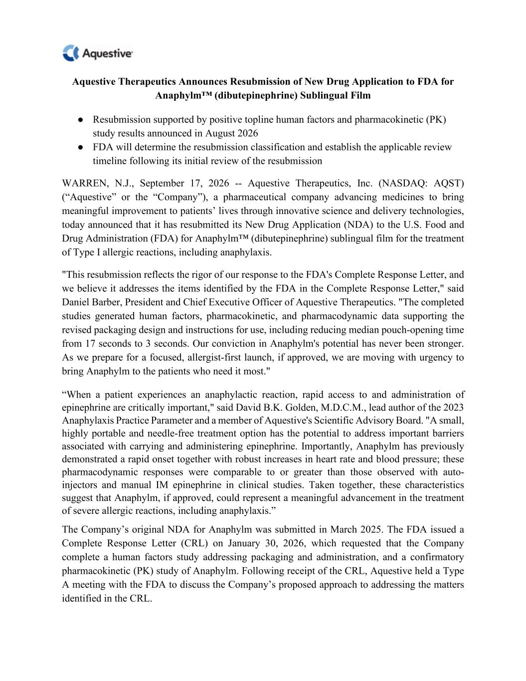

Aquestive Therapeutics Announces Resubmission of New Drug Application to FDA for Anaphylm™ (dibutepinephrine) Sublingual Film ● Resubmission supported by positive topline human factors and pharmacokinetic (PK) study results announced in August 2026 ● FDA will determine the resubmission classification and establish the applicable review timeline following its initial review of the resubmission WARREN, N.J., September 17, 2026 -- Aquestive Therapeutics, Inc. (NASDAQ: AQST) (“Aquestive” or the “Company”), a pharmaceutical company advancing medicines to bring meaningful improvement to patients’ lives through innovative science and delivery technologies, today announced that it has resubmitted its New Drug Application (NDA) to the U.S. Food and Drug Administration (FDA) for Anaphylm™ (dibutepinephrine) sublingual film for the treatment of Type I allergic reactions, including anaphylaxis. "This resubmission reflects the rigor of our response to the FDA's Complete Response Letter, and we believe it addresses the items identified by the FDA in the Complete Response Letter," said Daniel Barber, President and Chief Executive Officer of Aquestive Therapeutics. "The completed studies generated human factors, pharmacokinetic, and pharmacodynamic data supporting the revised packaging design and instructions for use, including reducing median pouch-opening time from 17 seconds to 3 seconds. Our conviction in Anaphylm's potential has never been stronger. As we prepare for a focused, allergist-first launch, if approved, we are moving with urgency to bring Anaphylm to the patients who need it most." “When a patient experiences an anaphylactic reaction, rapid access to and administration of epinephrine are critically important," said David B.K. Golden, M.D.C.M., lead author of the 2023 Anaphylaxis Practice Parameter and a member of Aquestive's Scientific Advisory Board. "A small, highly portable and needle-free treatment option has the potential to address important barriers associated with carrying and administering epinephrine. Importantly, Anaphylm has previously demonstrated a rapid onset together with robust increases in heart rate and blood pressure; these pharmacodynamic responses were comparable to or greater than those observed with auto- injectors and manual IM epinephrine in clinical studies. Taken together, these characteristics suggest that Anaphylm, if approved, could represent a meaningful advancement in the treatment of severe allergic reactions, including anaphylaxis.” The Company’s original NDA for Anaphylm was submitted in March 2025. The FDA issued a Complete Response Letter (CRL) on January 30, 2026, which requested that the Company complete a human factors study addressing packaging and administration, and a confirmatory pharmacokinetic (PK) study of Anaphylm. Following receipt of the CRL, Aquestive held a Type A meeting with the FDA to discuss the Company’s proposed approach to addressing the matters identified in the CRL.

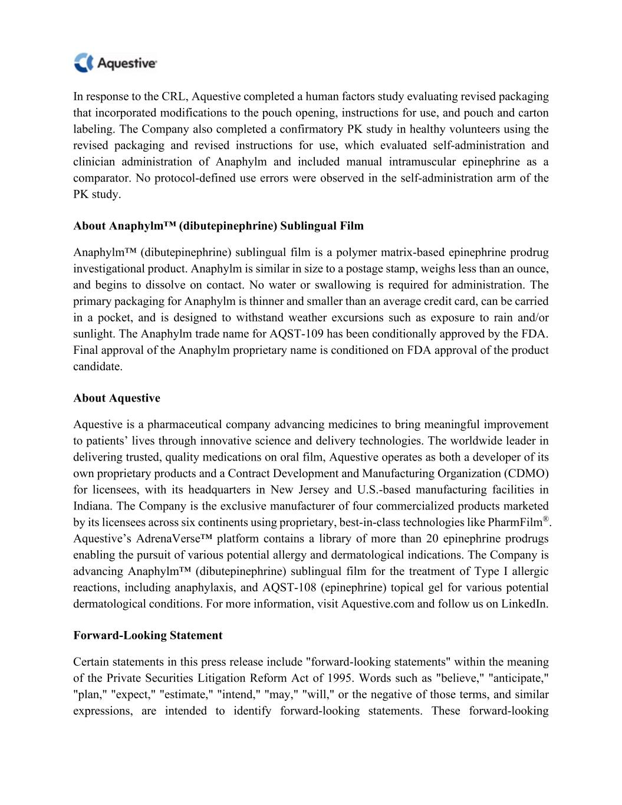
In response to the CRL, Aquestive completed a human factors study evaluating revised packaging that incorporated modifications to the pouch opening, instructions for use, and pouch and carton labeling. The Company also completed a confirmatory PK study in healthy volunteers using the revised packaging and revised instructions for use, which evaluated self-administration and clinician administration of Anaphylm and included manual intramuscular epinephrine as a comparator. No protocol-defined use errors were observed in the self-administration arm of the PK study. About Anaphylm™ (dibutepinephrine) Sublingual Film Anaphylm™ (dibutepinephrine) sublingual film is a polymer matrix-based epinephrine prodrug investigational product. Anaphylm is similar in size to a postage stamp, weighs less than an ounce, and begins to dissolve on contact. No water or swallowing is required for administration. The primary packaging for Anaphylm is thinner and smaller than an average credit card, can be carried in a pocket, and is designed to withstand weather excursions such as exposure to rain and/or sunlight. The Anaphylm trade name for AQST-109 has been conditionally approved by the FDA. Final approval of the Anaphylm proprietary name is conditioned on FDA approval of the product candidate. About Aquestive Aquestive is a pharmaceutical company advancing medicines to bring meaningful improvement to patients’ lives through innovative science and delivery technologies. The worldwide leader in delivering trusted, quality medications on oral film, Aquestive operates as both a developer of its own proprietary products and a Contract Development and Manufacturing Organization (CDMO) for licensees, with its headquarters in New Jersey and U.S.-based manufacturing facilities in Indiana. The Company is the exclusive manufacturer of four commercialized products marketed by its licensees across six continents using proprietary, best-in-class technologies like PharmFilm®. Aquestive’s AdrenaVerse™ platform contains a library of more than 20 epinephrine prodrugs enabling the pursuit of various potential allergy and dermatological indications. The Company is advancing Anaphylm™ (dibutepinephrine) sublingual film for the treatment of Type I allergic reactions, including anaphylaxis, and AQST-108 (epinephrine) topical gel for various potential dermatological conditions. For more information, visit Aquestive.com and follow us on LinkedIn. Forward-Looking Statement Certain statements in this press release include "forward-looking statements" within the meaning of the Private Securities Litigation Reform Act of 1995. Words such as "believe," "anticipate," "plan," "expect," "estimate," "intend," "may," "will," or the negative of those terms, and similar expressions, are intended to identify forward-looking statements. These forward-looking

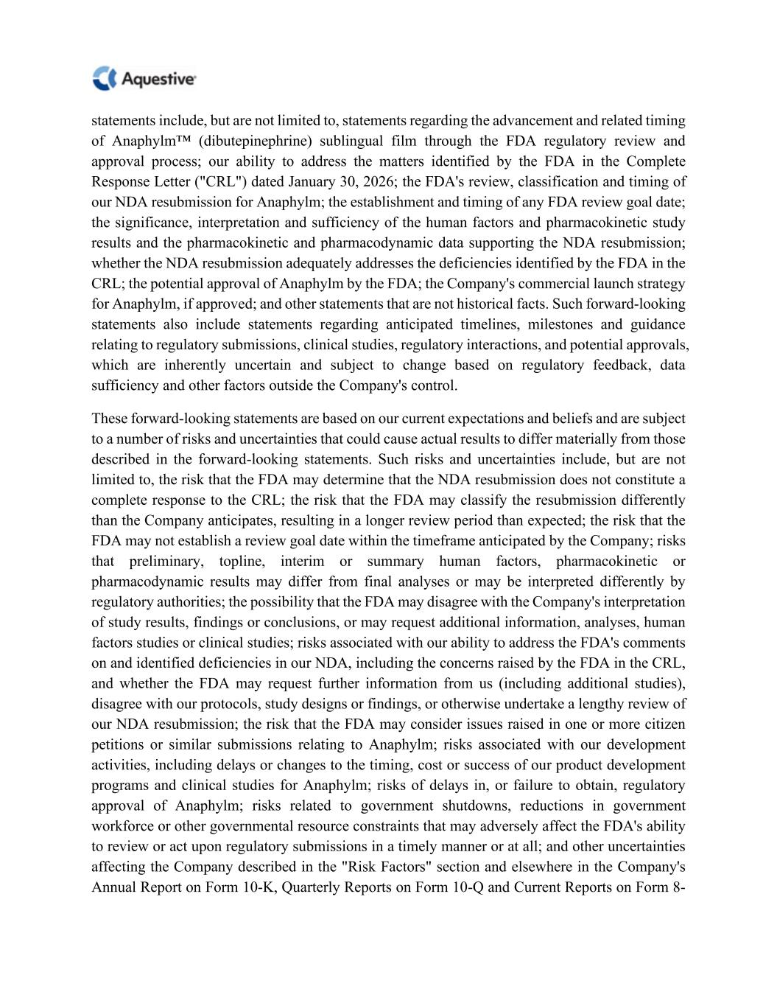
statements include, but are not limited to, statements regarding the advancement and related timing of Anaphylm™ (dibutepinephrine) sublingual film through the FDA regulatory review and approval process; our ability to address the matters identified by the FDA in the Complete Response Letter ("CRL") dated January 30, 2026; the FDA's review, classification and timing of our NDA resubmission for Anaphylm; the establishment and timing of any FDA review goal date; the significance, interpretation and sufficiency of the human factors and pharmacokinetic study results and the pharmacokinetic and pharmacodynamic data supporting the NDA resubmission; whether the NDA resubmission adequately addresses the deficiencies identified by the FDA in the CRL; the potential approval of Anaphylm by the FDA; the Company's commercial launch strategy for Anaphylm, if approved; and other statements that are not historical facts. Such forward-looking statements also include statements regarding anticipated timelines, milestones and guidance relating to regulatory submissions, clinical studies, regulatory interactions, and potential approvals, which are inherently uncertain and subject to change based on regulatory feedback, data sufficiency and other factors outside the Company's control. These forward-looking statements are based on our current expectations and beliefs and are subject to a number of risks and uncertainties that could cause actual results to differ materially from those described in the forward-looking statements. Such risks and uncertainties include, but are not limited to, the risk that the FDA may determine that the NDA resubmission does not constitute a complete response to the CRL; the risk that the FDA may classify the resubmission differently than the Company anticipates, resulting in a longer review period than expected; the risk that the FDA may not establish a review goal date within the timeframe anticipated by the Company; risks that preliminary, topline, interim or summary human factors, pharmacokinetic or pharmacodynamic results may differ from final analyses or may be interpreted differently by regulatory authorities; the possibility that the FDA may disagree with the Company's interpretation of study results, findings or conclusions, or may request additional information, analyses, human factors studies or clinical studies; risks associated with our ability to address the FDA's comments on and identified deficiencies in our NDA, including the concerns raised by the FDA in the CRL, and whether the FDA may request further information from us (including additional studies), disagree with our protocols, study designs or findings, or otherwise undertake a lengthy review of our NDA resubmission; the risk that the FDA may consider issues raised in one or more citizen petitions or similar submissions relating to Anaphylm; risks associated with our development activities, including delays or changes to the timing, cost or success of our product development programs and clinical studies for Anaphylm; risks of delays in, or failure to obtain, regulatory approval of Anaphylm; risks related to government shutdowns, reductions in government workforce or other governmental resource constraints that may adversely affect the FDA's ability to review or act upon regulatory submissions in a timely manner or at all; and other uncertainties affecting the Company described in the "Risk Factors" section and elsewhere in the Company's Annual Report on Form 10-K, Quarterly Reports on Form 10-Q and Current Reports on Form 8-

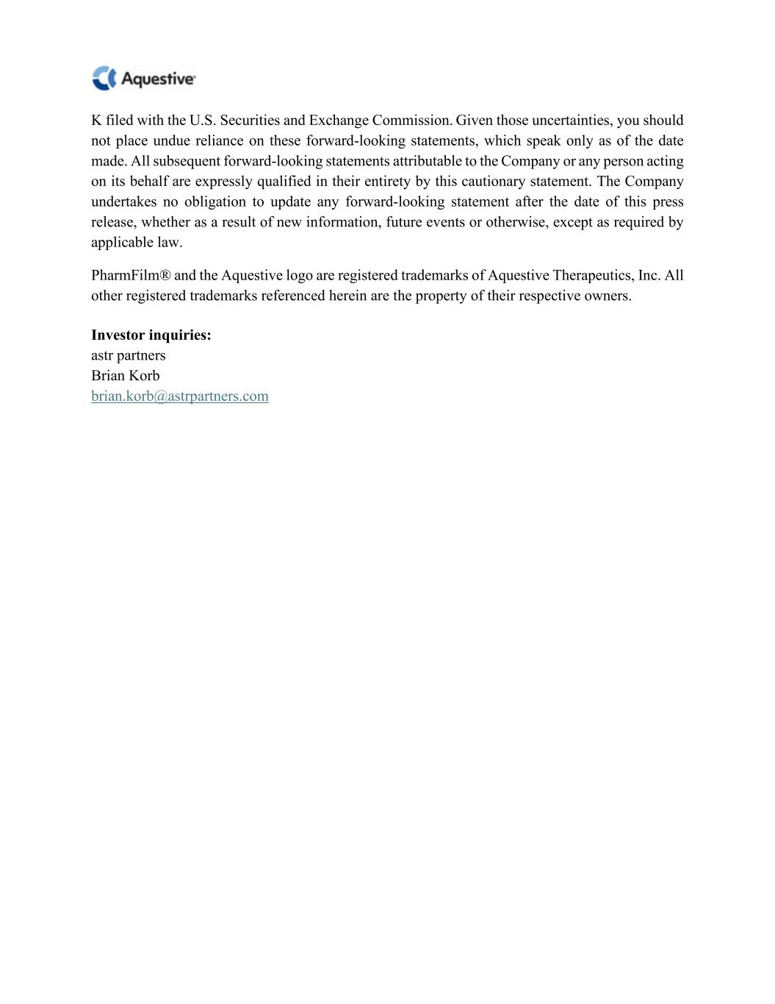
K filed with the U.S. Securities and Exchange Commission. Given those uncertainties, you should not place undue reliance on these forward-looking statements, which speak only as of the date made. All subsequent forward-looking statements attributable to the Company or any person acting on its behalf are expressly qualified in their entirety by this cautionary statement. The Company undertakes no obligation to update any forward-looking statement after the date of this press release, whether as a result of new information, future events or otherwise, except as required by applicable law. PharmFilm® and the Aquestive logo are registered trademarks of Aquestive Therapeutics, Inc. All other registered trademarks referenced herein are the property of their respective owners. Investor inquiries: astr partners Brian Korb brian.korb@astrpartners.com


H.C. Wainwright 28th Annual Global Investment Conference September 14, 2026

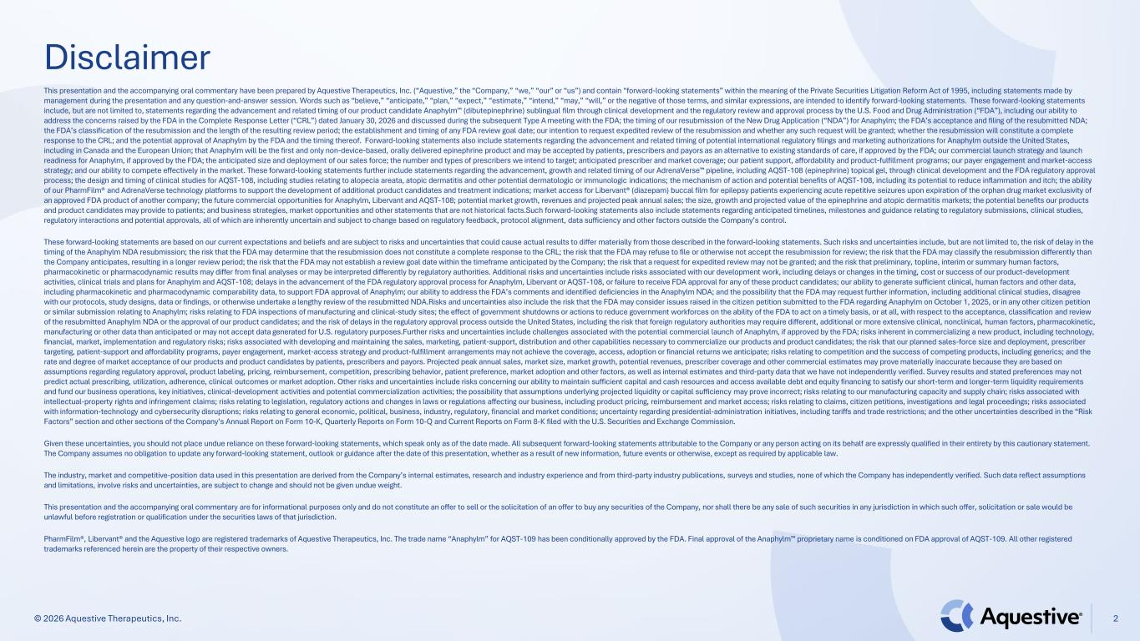
© 2026 Aquestive Therapeutics, Inc. Disclaimer 2 This presentation and the accompanying oral commentary have been prepared by Aquestive Therapeutics, Inc. (“Aquestive,” the “Company,” “we,” “our” or “us”) and contain “forward-looking statements” within the meaning of the Private Securities Litigation Reform Act of 1995, including statements made by management during the presentation and any question-and-answer session. Words such as “believe,” “anticipate,” “plan,” “expect,” “estimate,” “intend,” “may,” “will,” or the negative of those terms, and similar expressions, are intended to identify forward-looking statements. These forward-looking statements include, but are not limited to, statements regarding the advancement and related timing of our product candidate Anaphylm (dibutepinephrine) sublingual film through clinical development and the regulatory review and approval process by the U.S. Food and Drug Administration (“FDA”), including our ability to address the concerns raised by the FDA in the Complete Response Letter (“CRL”) dated January 30, 2026 and discussed during the subsequent Type A meeting with the FDA; the timing of our resubmission of the New Drug Application (“NDA”) for Anaphylm; the FDA’s acceptance and filing of the resubmitted NDA; the FDA’s classification of the resubmission and the length of the resulting review period; the establishment and timing of any FDA review goal date; our intention to request expedited review of the resubmission and whether any such request will be granted; whether the resubmission will constitute a complete response to the CRL; and the potential approval of Anaphylm by the FDA and the timing thereof. Forward-looking statements also include statements regarding the advancement and related timing of potential international regulatory filings and marketing authorizations for Anaphylm outside the United States, including in Canada and the European Union; that Anaphylm will be the first and only non-device-based, orally delivered epinephrine product and may be accepted by patients, prescribers and payors as an alternative to existing standards of care, if approved by the FDA; our commercial launch strategy and launch readiness for Anaphylm, if approved by the FDA; the anticipated size and deployment of our sales force; the number and types of prescribers we intend to target; anticipated prescriber and market coverage; our patient support, affordability and product-fulfillment programs; our payer engagement and market-access strategy; and our ability to compete effectively in the market. These forward-looking statements further include statements regarding the advancement, growth and related timing of our AdrenaVerse pipeline, including AQST-108 (epinephrine) topical gel, through clinical development and the FDA regulatory approval process; the design and timing of clinical studies for AQST-108, including studies relating to alopecia areata, atopic dermatitis and other potential dermatologic or immunologic indications; the mechanism of action and potential benefits of AQST-108, including its potential to reduce inflammation and itch; the ability of our PharmFilm® and AdrenaVerse technology platforms to support the development of additional product candidates and treatment indications; market access for Libervant® (diazepam) buccal film for epilepsy patients experiencing acute repetitive seizures upon expiration of the orphan drug market exclusivity of an approved FDA product of another company; the future commercial opportunities for Anaphylm, Libervant and AQST-108; potential market growth, revenues and projected peak annual sales; the size, growth and projected value of the epinephrine and atopic dermatitis markets; the potential benefits our products and product candidates may provide to patients; and business strategies, market opportunities and other statements that are not historical facts.Such forward-looking statements also include statements regarding anticipated timelines, milestones and guidance relating to regulatory submissions, clinical studies, regulatory interactions and potential approvals, all of which are inherently uncertain and subject to change based on regulatory feedback, protocol alignment, data sufficiency and other factors outside the Company’s control. These forward-looking statements are based on our current expectations and beliefs and are subject to risks and uncertainties that could cause actual results to differ materially from those described in the forward-looking statements. Such risks and uncertainties include, but are not limited to, the risk of delay in the timing of the Anaphylm NDA resubmission; the risk that the FDA may determine that the resubmission does not constitute a complete response to the CRL; the risk that the FDA may refuse to file or otherwise not accept the resubmission for review; the risk that the FDA may classify the resubmission differently than the Company anticipates, resulting in a longer review period; the risk that the FDA may not establish a review goal date within the timeframe anticipated by the Company; the risk that a request for expedited review may not be granted; and the risk that preliminary, topline, interim or summary human factors, pharmacokinetic or pharmacodynamic results may differ from final analyses or may be interpreted differently by regulatory authorities. Additional risks and uncertainties include risks associated with our development work, including delays or changes in the timing, cost or success of our product-development activities, clinical trials and plans for Anaphylm and AQST-108; delays in the advancement of the FDA regulatory approval process for Anaphylm, Libervant or AQST-108, or failure to receive FDA approval for any of these product candidates; our ability to generate sufficient clinical, human factors and other data, including pharmacokinetic and pharmacodynamic comparability data, to support FDA approval of Anaphylm; our ability to address the FDA’s comments and identified deficiencies in the Anaphylm NDA; and the possibility that the FDA may request further information, including additional clinical studies, disagree with our protocols, study designs, data or findings, or otherwise undertake a lengthy review of the resubmitted NDA.Risks and uncertainties also include the risk that the FDA may consider issues raised in the citizen petition submitted to the FDA regarding Anaphylm on October 1, 2025, or in any other citizen petition or similar submission relating to Anaphylm; risks relating to FDA inspections of manufacturing and clinical-study sites; the effect of government shutdowns or actions to reduce government workforces on the ability of the FDA to act on a timely basis, or at all, with respect to the acceptance, classification and review of the resubmitted Anaphylm NDA or the approval of our product candidates; and the risk of delays in the regulatory approval process outside the United States, including the risk that foreign regulatory authorities may require different, additional or more extensive clinical, nonclinical, human factors, pharmacokinetic, manufacturing or other data than anticipated or may not accept data generated for U.S. regulatory purposes.Further risks and uncertainties include challenges associated with the potential commercial launch of Anaphylm, if approved by the FDA; risks inherent in commercializing a new product, including technology, financial, market, implementation and regulatory risks; risks associated with developing and maintaining the sales, marketing, patient-support, distribution and other capabilities necessary to commercialize our products and product candidates; the risk that our planned sales-force size and deployment, prescriber targeting, patient-support and affordability programs, payer engagement, market-access strategy and product-fulfillment arrangements may not achieve the coverage, access, adoption or financial returns we anticipate; risks relating to competition and the success of competing products, including generics; and the rate and degree of market acceptance of our products and product candidates by patients, prescribers and payors. Projected peak annual sales, market size, market growth, potential revenues, prescriber coverage and other commercial estimates may prove materially inaccurate because they are based on assumptions regarding regulatory approval, product labeling, pricing, reimbursement, competition, prescribing behavior, patient preference, market adoption and other factors, as well as internal estimates and third-party data that we have not independently verified. Survey results and stated preferences may not predict actual prescribing, utilization, adherence, clinical outcomes or market adoption. Other risks and uncertainties include risks concerning our ability to maintain sufficient capital and cash resources and access available debt and equity financing to satisfy our short-term and longer-term liquidity requirements and fund our business operations, key initiatives, clinical-development activities and potential commercialization activities; the possibility that assumptions underlying projected liquidity or capital sufficiency may prove incorrect; risks relating to our manufacturing capacity and supply chain; risks associated with intellectual-property rights and infringement claims; risks relating to legislation, regulatory actions and changes in laws or regulations affecting our business, including product pricing, reimbursement and market access; risks relating to claims, citizen petitions, investigations and legal proceedings; risks associated with information-technology and cybersecurity disruptions; risks relating to general economic, political, business, industry, regulatory, financial and market conditions; uncertainty regarding presidential-administration initiatives, including tariffs and trade restrictions; and the other uncertainties described in the “Risk Factors” section and other sections of the Company’s Annual Report on Form 10-K, Quarterly Reports on Form 10-Q and Current Reports on Form 8-K filed with the U.S. Securities and Exchange Commission. Given these uncertainties, you should not place undue reliance on these forward-looking statements, which speak only as of the date made. All subsequent forward-looking statements attributable to the Company or any person acting on its behalf are expressly qualified in their entirety by this cautionary statement. The Company assumes no obligation to update any forward-looking statement, outlook or guidance after the date of this presentation, whether as a result of new information, future events or otherwise, except as required by applicable law. The industry, market and competitive-position data used in this presentation are derived from the Company’s internal estimates, research and industry experience and from third-party industry publications, surveys and studies, none of which the Company has independently verified. Such data reflect assumptions and limitations, involve risks and uncertainties, are subject to change and should not be given undue weight. This presentation and the accompanying oral commentary are for informational purposes only and do not constitute an offer to sell or the solicitation of an offer to buy any securities of the Company, nor shall there be any sale of such securities in any jurisdiction in which such offer, solicitation or sale would be unlawful before registration or qualification under the securities laws of that jurisdiction. PharmFilm®, Libervant® and the Aquestive logo are registered trademarks of Aquestive Therapeutics, Inc. The trade name “Anaphylm” for AQST-109 has been conditionally approved by the FDA. Final approval of the Anaphylm proprietary name is conditioned on FDA approval of AQST-109. All other registered trademarks referenced herein are the property of their respective owners.

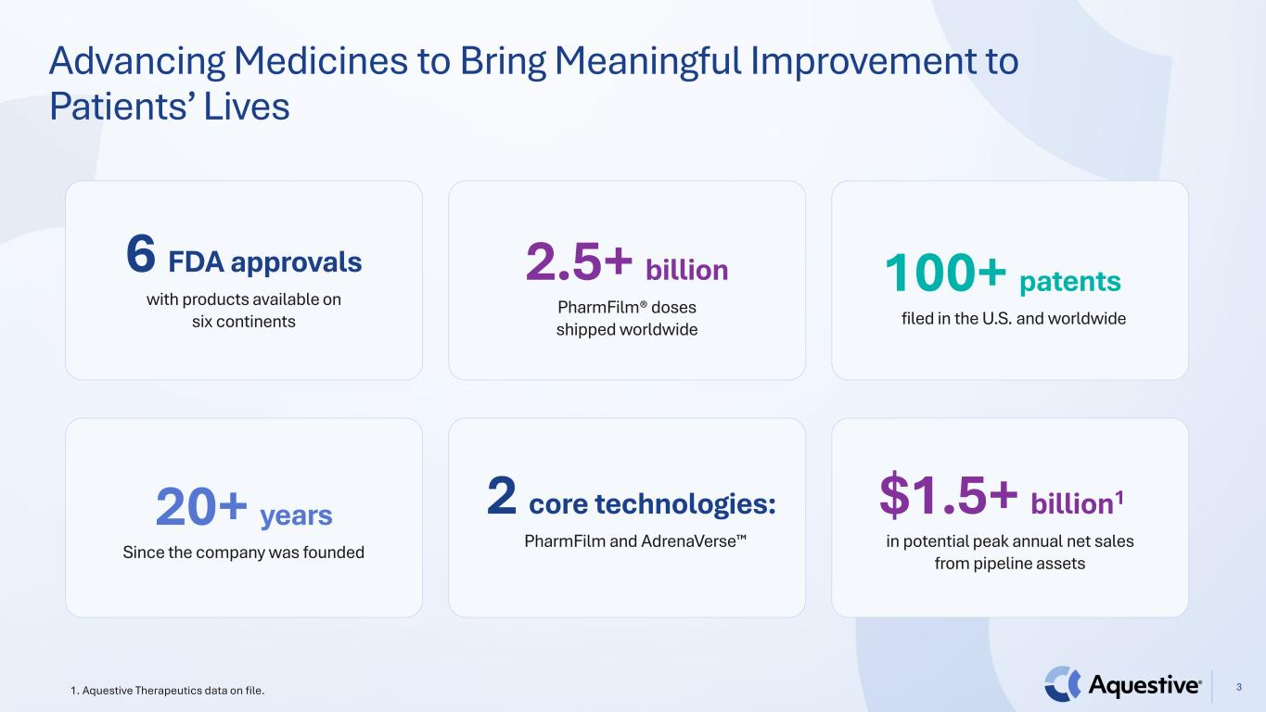
Advancing Medicines to Bring Meaningful Improvement to Patients’ Lives 31. Aquestive Therapeutics data on file. 6 FDA approvals with products available on six continents 2.5+ billion PharmFilm® doses shipped worldwide 100+ patents filed in the U.S. and worldwide 20+ years Since the company was founded 2 core technologies: PharmFilm and AdrenaVerse $1.5+ billion1 in potential peak annual net sales from pipeline assets


Dedicated and Experienced Leadership Team 4 Daniel Barber President, CEO & Director Matthew Greenhawt Chief Medical Officer Peter Boyd Chief People Officer Melina Cioffi SVP, Regulatory Affairs Sherry Korczynski Chief Commercial Officer Matthew Davis Chief Development Officer Ernie Toth Chief Financial Officer Thomas A. Zalewski Chief Legal Officer, Chief Compliance Officer Cassie Jung Chief Operating Officer

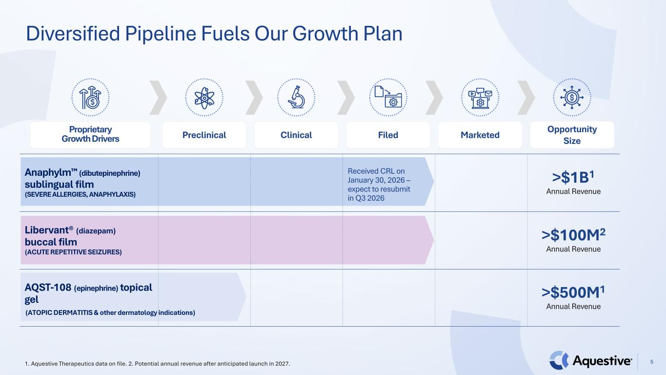
Diversified Pipeline Fuels Our Growth Plan 51. Aquestive Therapeutics data on file. 2. Potential annual revenue after anticipated launch in 2027. Anaphylm (dibutepinephrine) sublingual film (SEVERE ALLERGIES, ANAPHYLAXIS) Received CRL on January 30, 2026 – expect to resubmit in Q3 2026 >$1B1 Annual Revenue Libervant® (diazepam) buccal film (ACUTE REPETITIVE SEIZURES) >$100M2 Annual Revenue AQST-108 (epinephrine) topical gel >$500M1 Annual Revenue Proprietary Growth Drivers Preclinical Clinical Filed Marketed Opportunity Size (ATOPIC DERMATITIS & other dermatology indications)

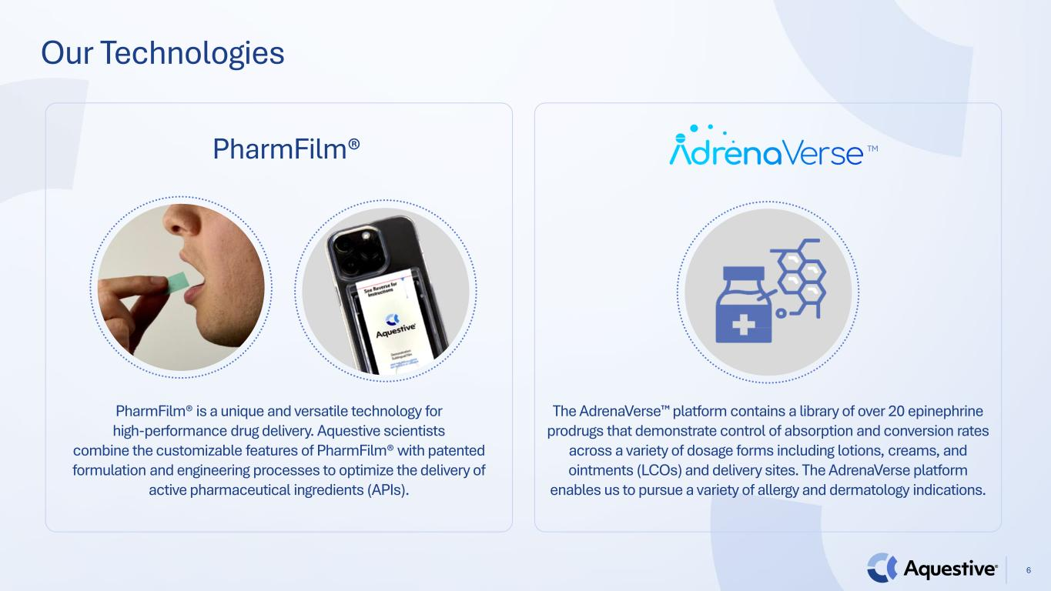
Our Technologies 6 PharmFilm® PharmFilm® is a unique and versatile technology for high-performance drug delivery. Aquestive scientists combine the customizable features of PharmFilm® with patented formulation and engineering processes to optimize the delivery of active pharmaceutical ingredients (APIs). The AdrenaVerse platform contains a library of over 20 epinephrine prodrugs that demonstrate control of absorption and conversion rates across a variety of dosage forms including lotions, creams, and ointments (LCOs) and delivery sites. The AdrenaVerse platform enables us to pursue a variety of allergy and dermatology indications. TM

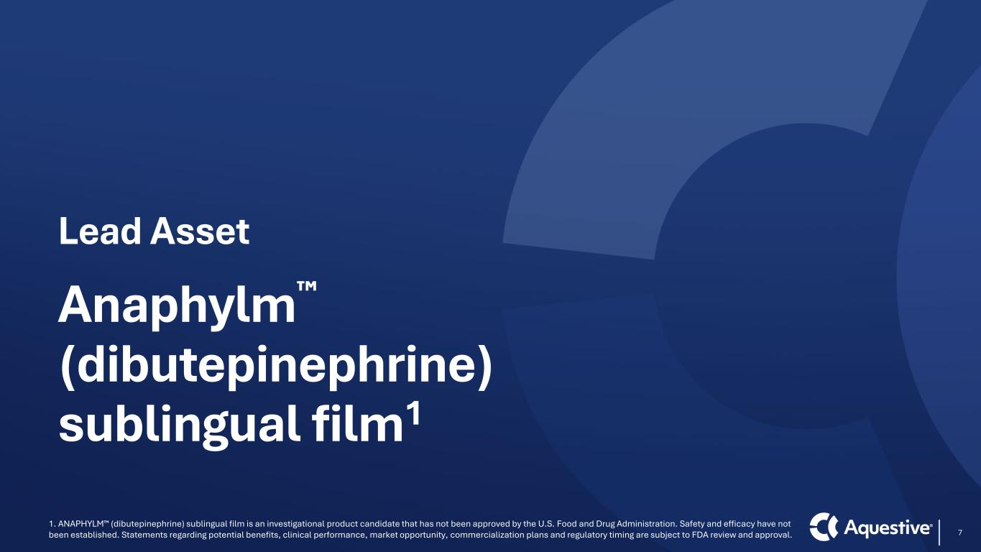
Lead Asset Anaphylm (dibutepinephrine) sublingual film1 7 1. ANAPHYLM (dibutepinephrine) sublingual film is an investigational product candidate that has not been approved by the U.S. Food and Drug Administration. Safety and efficacy have not been established. Statements regarding potential benefits, clinical performance, market opportunity, commercialization plans and regulatory timing are subject to FDA review and approval.

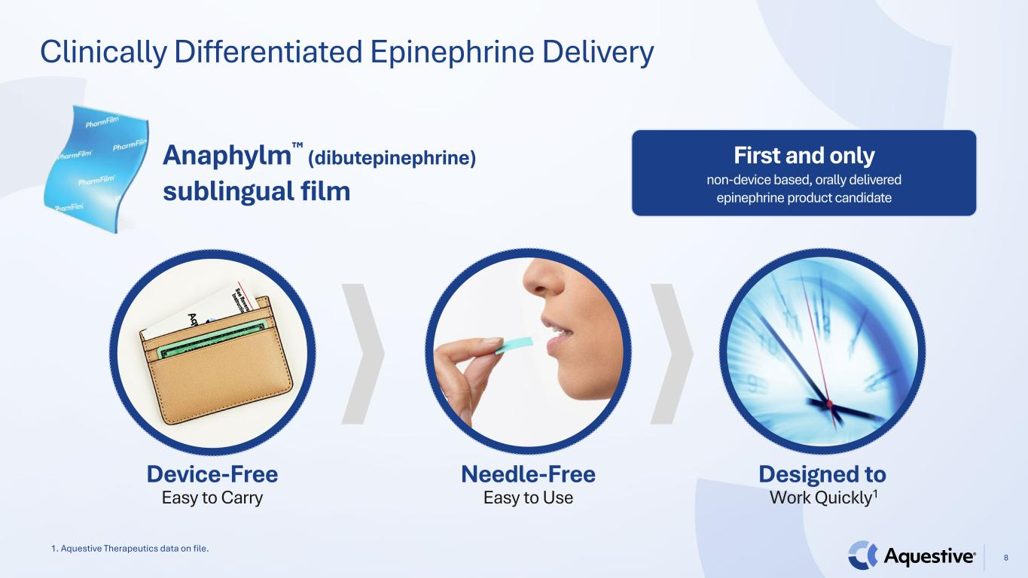
Clinically Differentiated Epinephrine Delivery 8 Anaphylm (dibutepinephrine) sublingual film Needle-Free Easy to Use Designed to Work Quickly1 Device-Free Easy to Carry First and only non-device based, orally delivered epinephrine product candidate 1. Aquestive Therapeutics data on file.

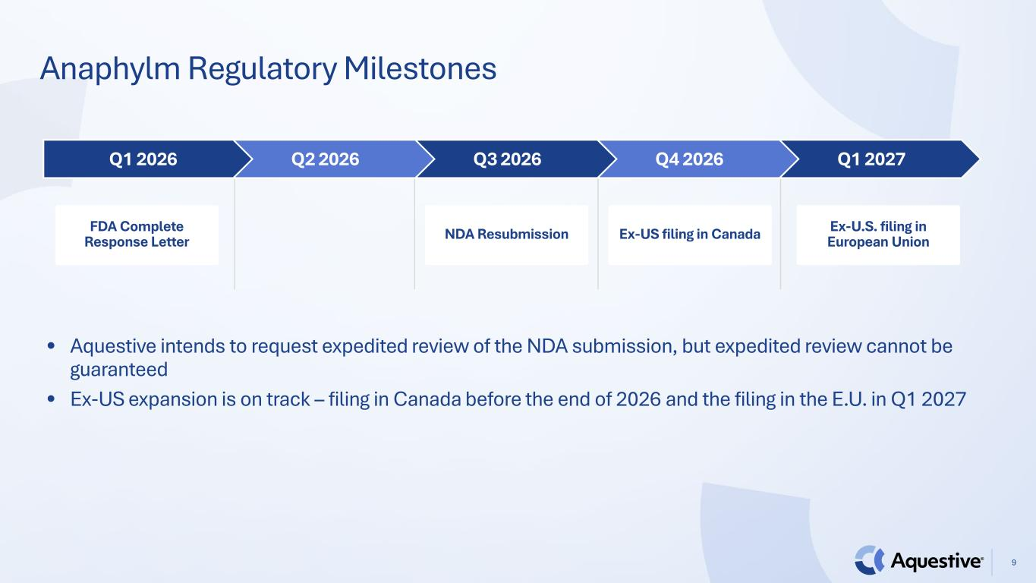
Anaphylm Regulatory Milestones 9 Q1 2027Q4 2026Q3 2026Q2 2026Q1 2026 NDA Resubmission Ex-US filing in Canada Ex-U.S. filing in European Union • Aquestive intends to request expedited review of the NDA submission, but expedited review cannot be guaranteed • Ex-US expansion is on track – filing in Canada before the end of 2026 and the filing in the E.U. in Q1 2027 FDA Complete Response Letter

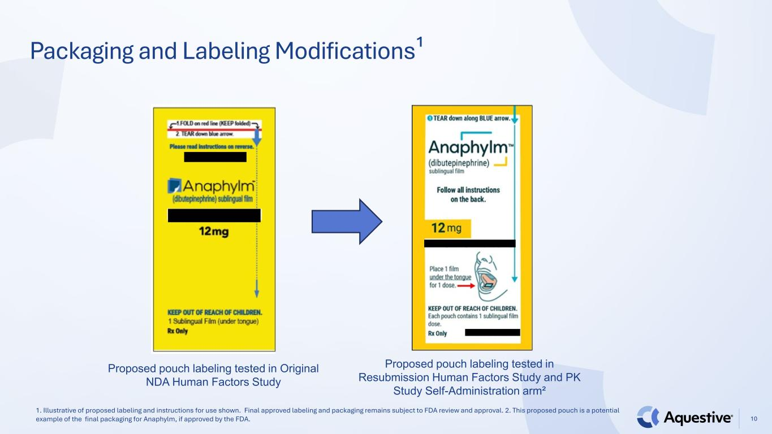
Packaging and Labeling Modifications¹ Proposed pouch labeling tested in Original NDA Human Factors Study Proposed pouch labeling tested in Resubmission Human Factors Study and PK Study Self-Administration arm² 1. Illustrative of proposed labeling and instructions for use shown. Final approved labeling and packaging remains subject to FDA review and approval. 2. This proposed pouch is a potential example of the final packaging for Anaphylm, if approved by the FDA. 10

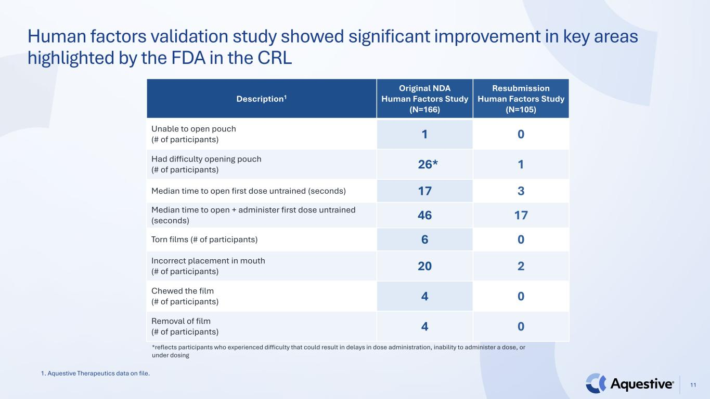
Human factors validation study showed significant improvement in key areas highlighted by the FDA in the CRL Description1 Original NDA Human Factors Study (N=166) Resubmission Human Factors Study (N=105) Unable to open pouch (# of participants) 1 0 Had difficulty opening pouch (# of participants) 26* 1 Median time to open first dose untrained (seconds) 17 3 Median time to open + administer first dose untrained (seconds) 46 17 Torn films (# of participants) 6 0 Incorrect placement in mouth (# of participants) 20 2 Chewed the film (# of participants) 4 0 Removal of film (# of participants) 4 0 *reflects participants who experienced difficulty that could result in delays in dose administration, inability to administer a dose, or under dosing 1. Aquestive Therapeutics data on file. 11

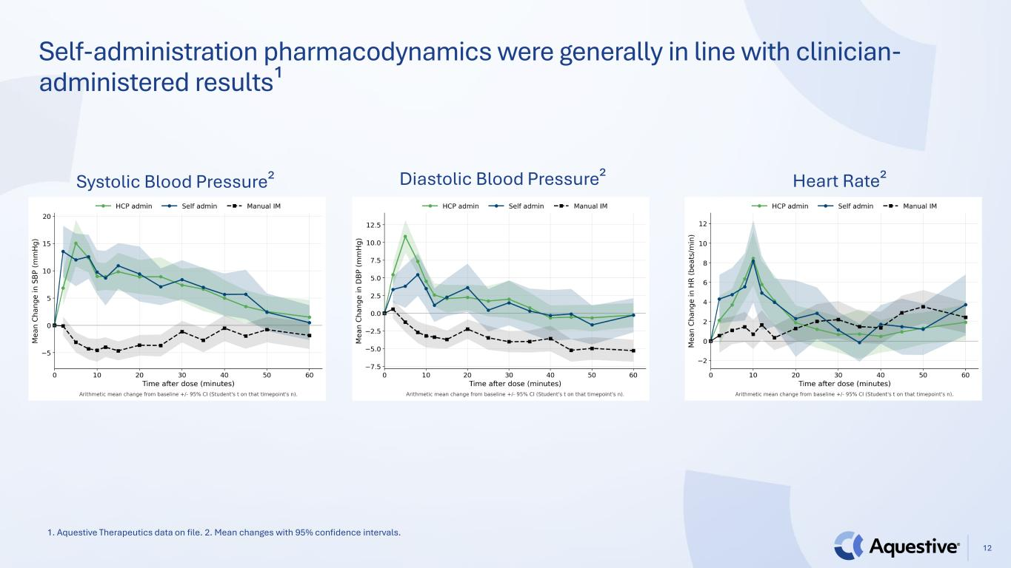
Self-administration pharmacodynamics were generally in line with clinician- administered results¹ Systolic Blood Pressure² Diastolic Blood Pressure² Heart Rate² 1. Aquestive Therapeutics data on file. 2. Mean changes with 95% confidence intervals. 12

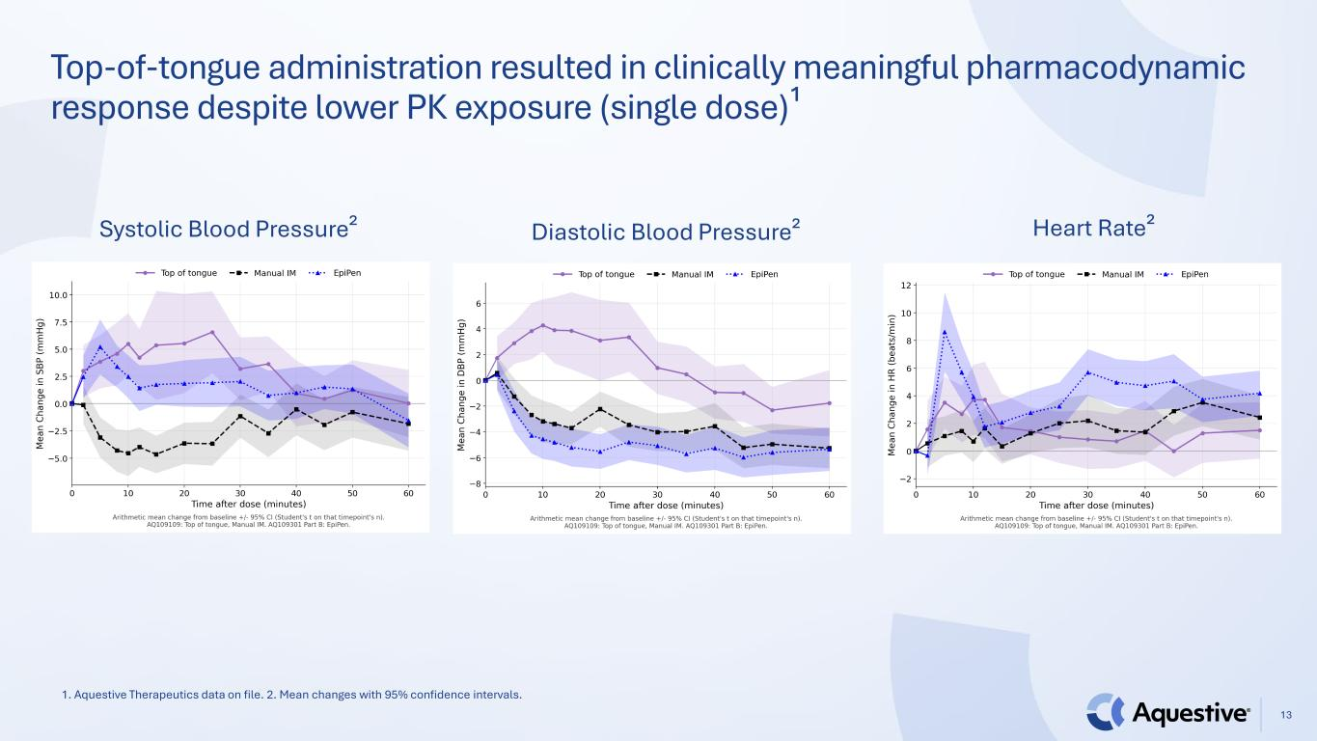
Top-of-tongue administration resulted in clinically meaningful pharmacodynamic response despite lower PK exposure (single dose)¹ Systolic Blood Pressure² Diastolic Blood Pressure² Heart Rate² 1. Aquestive Therapeutics data on file. 2. Mean changes with 95% confidence intervals. 13

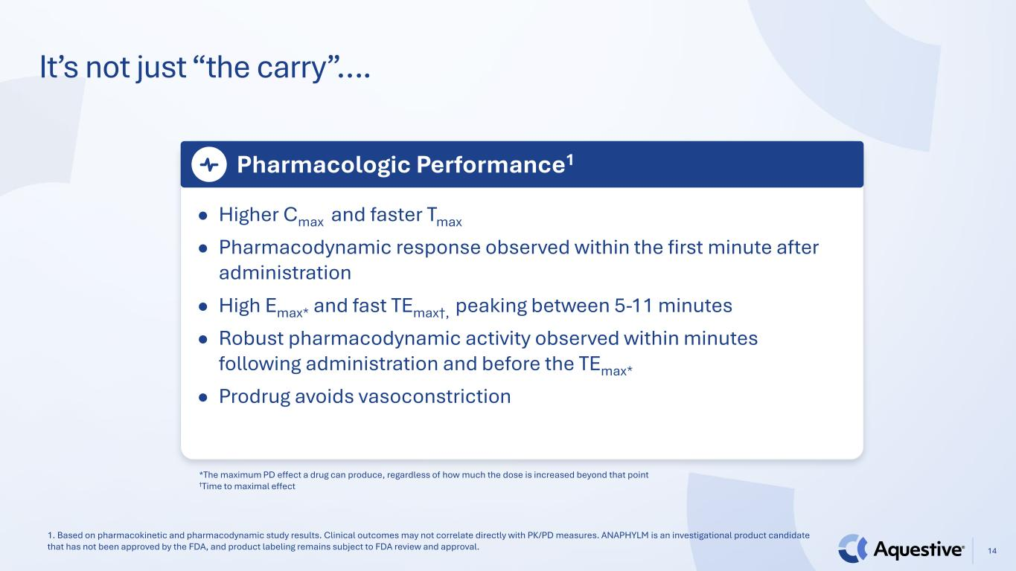
It’s not just “the carry”…. 14 Pharmacologic Performance1 ● Higher Cmax and faster Tmax ● Pharmacodynamic response observed within the first minute after administration ● High Emax* and fast TEmax†, peaking between 5-11 minutes ● Robust pharmacodynamic activity observed within minutes following administration and before the TEmax* ● Prodrug avoids vasoconstriction 1. Based on pharmacokinetic and pharmacodynamic study results. Clinical outcomes may not correlate directly with PK/PD measures. ANAPHYLM is an investigational product candidate that has not been approved by the FDA, and product labeling remains subject to FDA review and approval. *The maximum PD effect a drug can produce, regardless of how much the dose is increased beyond that point †Time to maximal effect

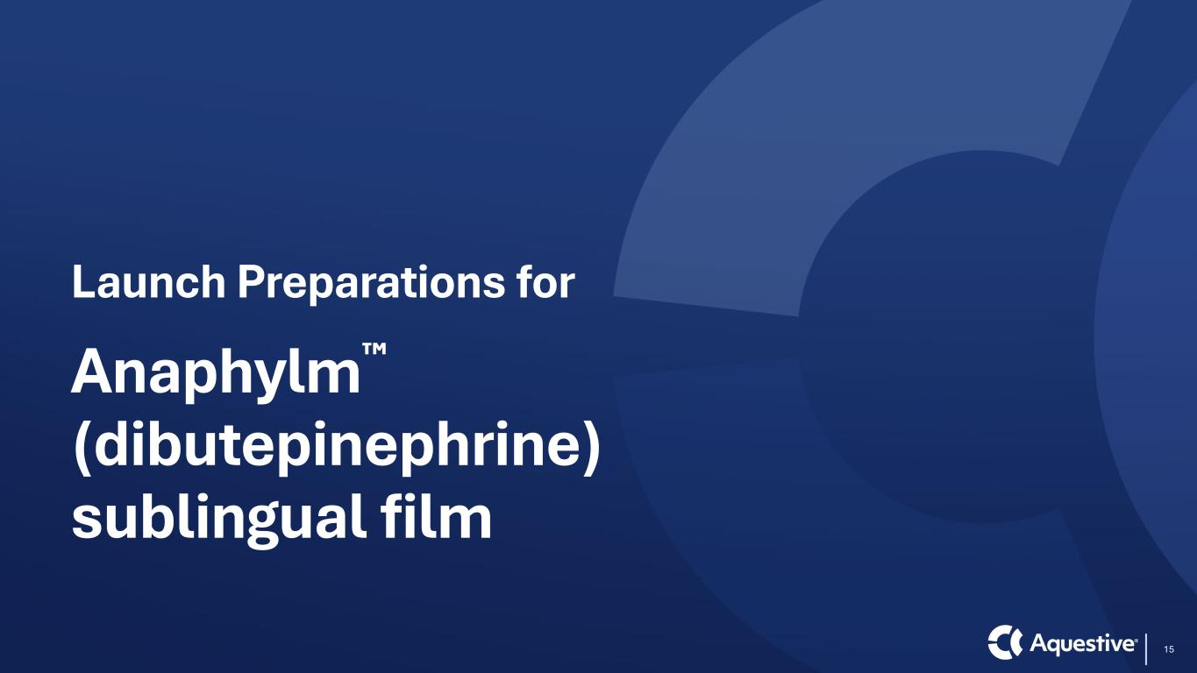
Launch Preparations for Anaphylm (dibutepinephrine) sublingual film 15

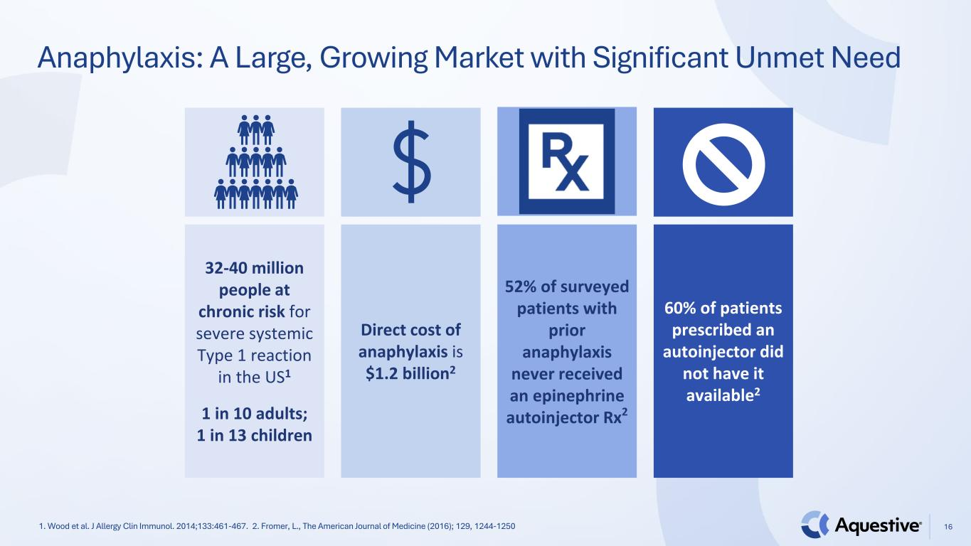
16 Anaphylaxis: A Large, Growing Market with Significant Unmet Need 32-40 million people at chronic risk for severe systemic Type 1 reaction in the US1 1 in 10 adults; 1 in 13 children Direct cost of anaphylaxis is $1.2 billion2 52% of surveyed patients with prior anaphylaxis never received an epinephrine autoinjector Rx2 60% of patients prescribed an autoinjector did not have it available2 1. Wood et al. J Allergy Clin Immunol. 2014;133:461-467. 2. Fromer, L., The American Journal of Medicine (2016); 129, 1244-1250

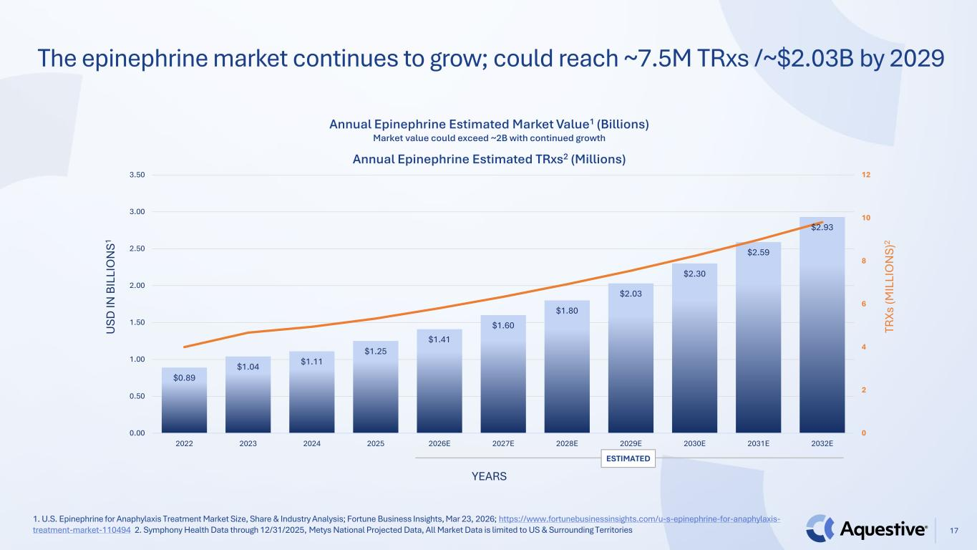
1. U.S. Epinephrine for Anaphylaxis Treatment Market Size, Share & Industry Analysis; Fortune Business Insights, Mar 23, 2026; https://www.fortunebusinessinsights.com/u-s-epinephrine-for-anaphylaxis- treatment-market-110494 2. Symphony Health Data through 12/31/2025, Metys National Projected Data, All Market Data is limited to US & Surrounding Territories The epinephrine market continues to grow; could reach ~7.5M TRxs /~$2.03B by 2029 $0.89 $1.04 $1.11 $1.25 $1.41 $1.60 $1.80 $2.03 $2.30 $2.59 $2.93 0 2 4 6 8 10 12 0.00 0.50 1.00 1.50 2.00 2.50 3.00 3.50 2022 2023 2024 2025 2026E 2027E 2028E 2029E 2030E 2031E 2032E Annual Epinephrine Estimated Market Value1 (Billions) Market value could exceed ~2B with continued growth Annual Epinephrine Estimated TRxs2 (Millions) U SD IN B IL LI O N S1 YEARS TR Xs (M IL LI O N S) 2 ESTIMATED 17

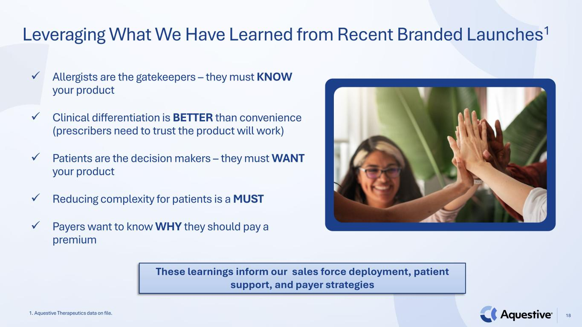
18 ✓ Allergists are the gatekeepers – they must KNOW your product ✓ Clinical differentiation is BETTER than convenience (prescribers need to trust the product will work) ✓ Patients are the decision makers – they must WANT your product ✓ Reducing complexity for patients is a MUST ✓ Payers want to know WHY they should pay a premium 1. Aquestive Therapeutics data on file. Leveraging What We Have Learned from Recent Branded Launches1 These learnings inform our sales force deployment, patient support, and payer strategies

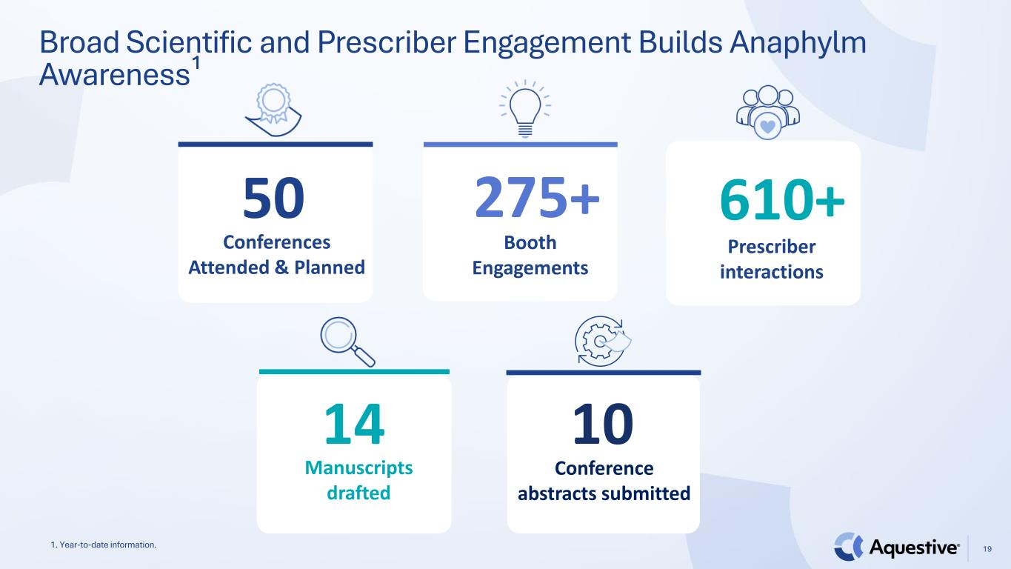
19 50 Conferences Attended & Planned 275+ Booth Engagements 610+ Prescriber interactions 14 Manuscripts drafted 10 Conference abstracts submitted Broad Scientific and Prescriber Engagement Builds Anaphylm Awareness¹ 1. Year-to-date information.

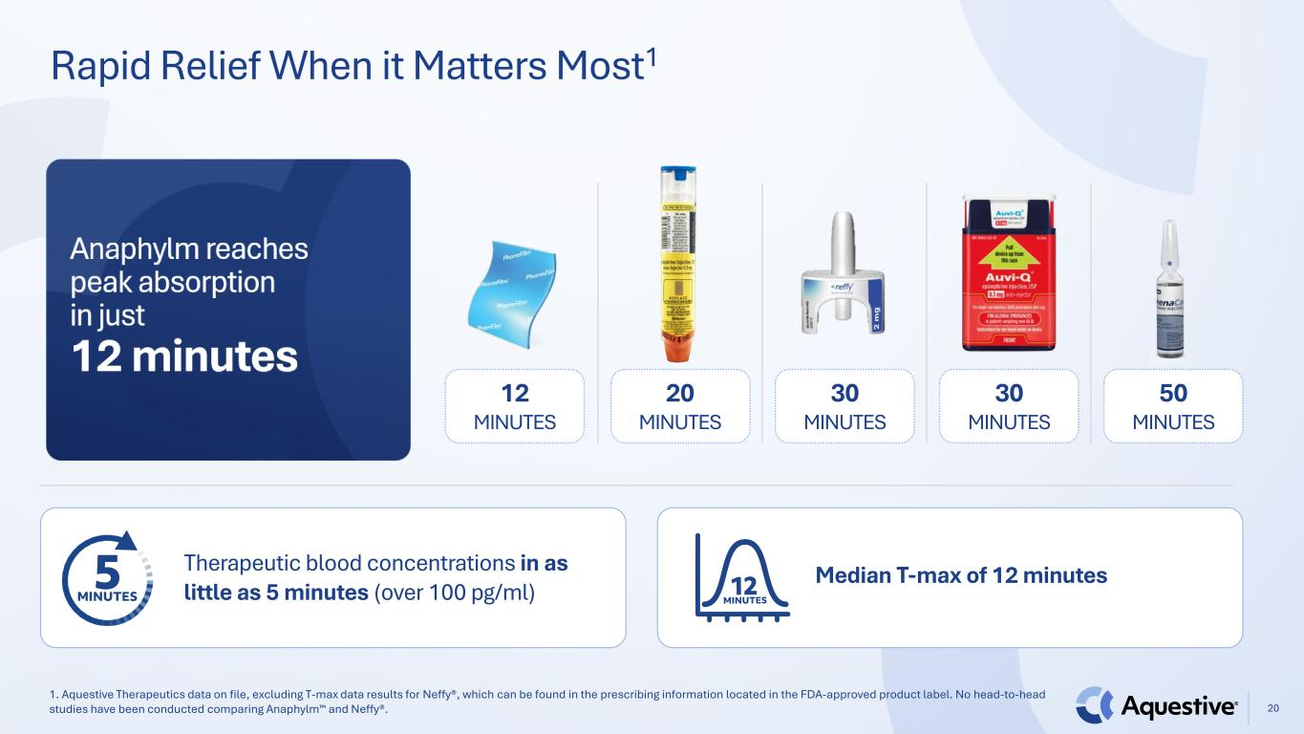
Rapid Relief When it Matters Most1 1. Aquestive Therapeutics data on file, excluding T-max data results for Neffy®, which can be found in the prescribing information located in the FDA-approved product label. No head-to-head studies have been conducted comparing Anaphylm and Neffy®. 20 12 MINUTES 20 MINUTES 30 MINUTES 30 MINUTES 50 MINUTES Therapeutic blood concentrations in as little as 5 minutes (over 100 pg/ml) Median T-max of 12 minutes

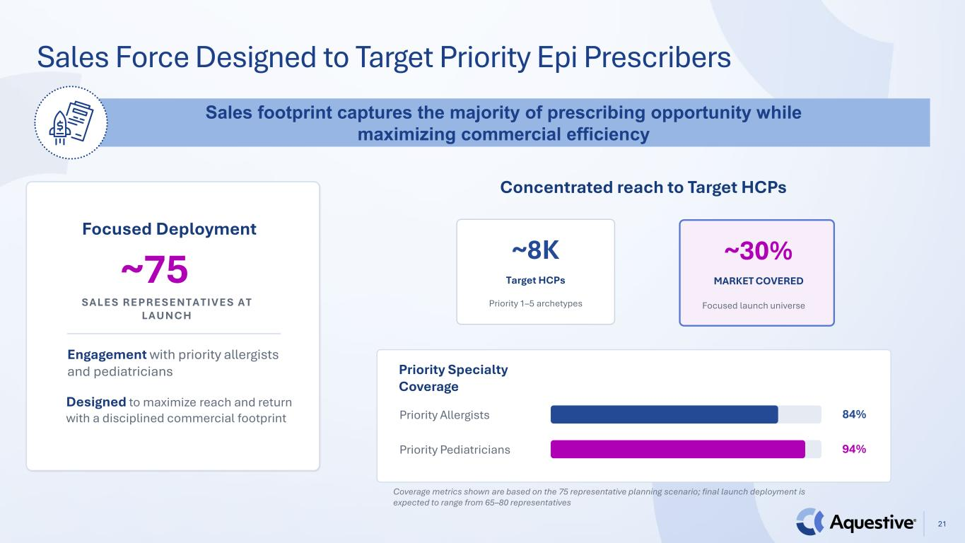
21 Sales footprint captures the majority of prescribing opportunity while maximizing commercial efficiency Focused Deployment ~75 SALES REPRESENTATIVES AT LAUNCH Designed to maximize reach and return with a disciplined commercial footprint Engagement with priority allergists and pediatricians Concentrated reach to Target HCPs ~8K Target HCPs Priority 1–5 archetypes ~30% MARKET COVERED Focused launch universe Priority Specialty Coverage Priority Allergists 84% Priority Pediatricians 94% Coverage metrics shown are based on the 75 representative planning scenario; final launch deployment is expected to range from 65–80 representatives Sales Force Designed to Target Priority Epi Prescribers

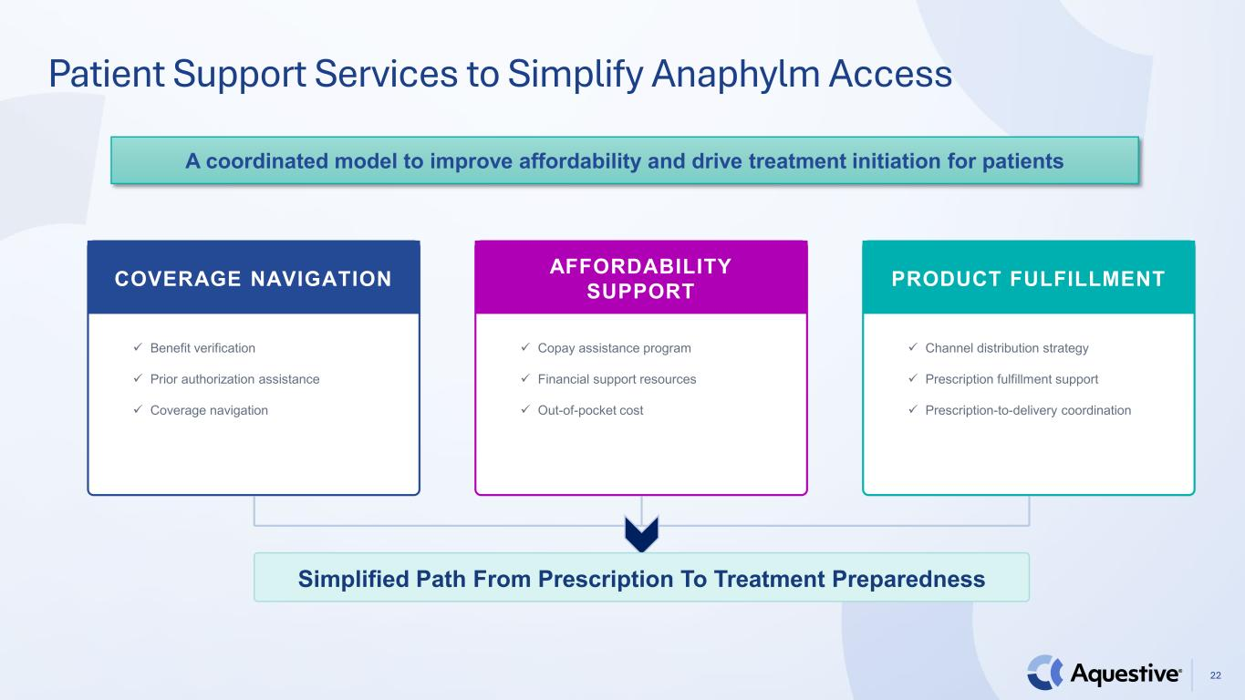
22 A coordinated model to improve affordability and drive treatment initiation for patients Patient Support Services to Simplify Anaphylm Access COVERAGE NAVIGATION ✓ Benefit verification ✓ Prior authorization assistance ✓ Coverage navigation AFFORDABILITY SUPPORT ✓ Copay assistance program ✓ Financial support resources ✓ Out-of-pocket cost PRODUCT FULFILLMENT ✓ Channel distribution strategy ✓ Prescription fulfillment support ✓ Prescription-to-delivery coordination Simplified Path From Prescription To Treatment Preparedness

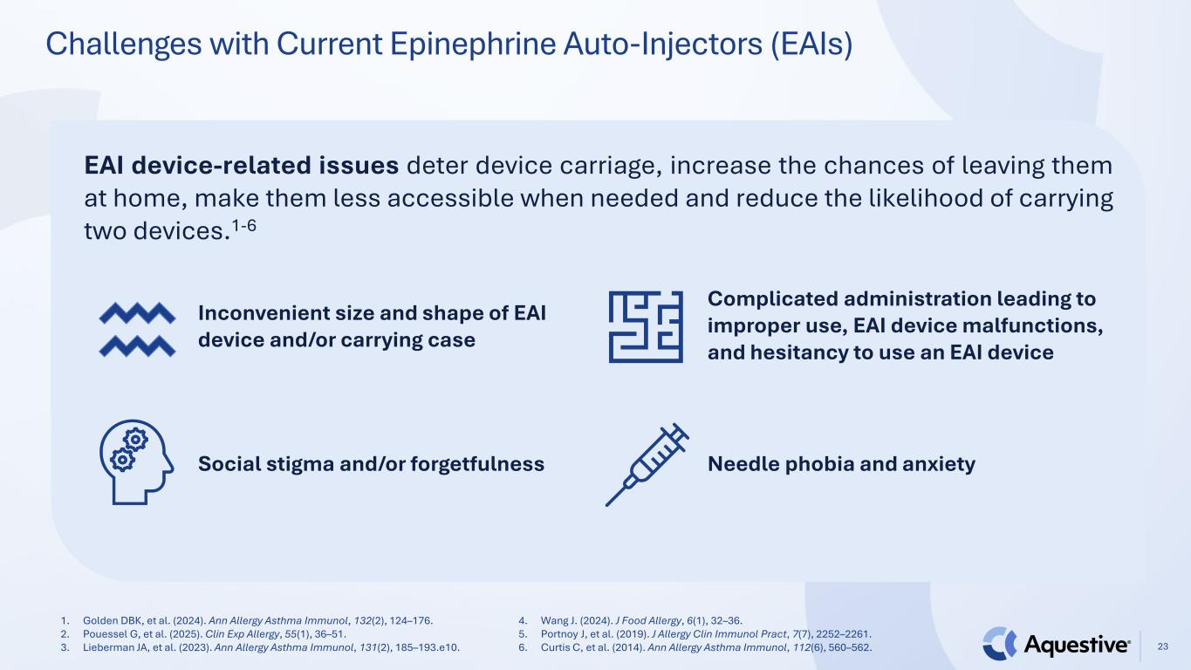
Challenges with Current Epinephrine Auto-Injectors (EAIs) 23 1. Golden DBK, et al. (2024). Ann Allergy Asthma Immunol, 132(2), 124–176. 2. Pouessel G, et al. (2025). Clin Exp Allergy, 55(1), 36–51. 3. Lieberman JA, et al. (2023). Ann Allergy Asthma Immunol, 131(2), 185–193.e10. 4. Wang J. (2024). J Food Allergy, 6(1), 32–36. 5. Portnoy J, et al. (2019). J Allergy Clin Immunol Pract, 7(7), 2252–2261. 6. Curtis C, et al. (2014). Ann Allergy Asthma Immunol, 112(6), 560–562. EAI device-related issues deter device carriage, increase the chances of leaving them at home, make them less accessible when needed and reduce the likelihood of carrying two devices.1-6 Inconvenient size and shape of EAI device and/or carrying case Social stigma and/or forgetfulness Complicated administration leading to improper use, EAI device malfunctions, and hesitancy to use an EAI device Needle phobia and anxiety

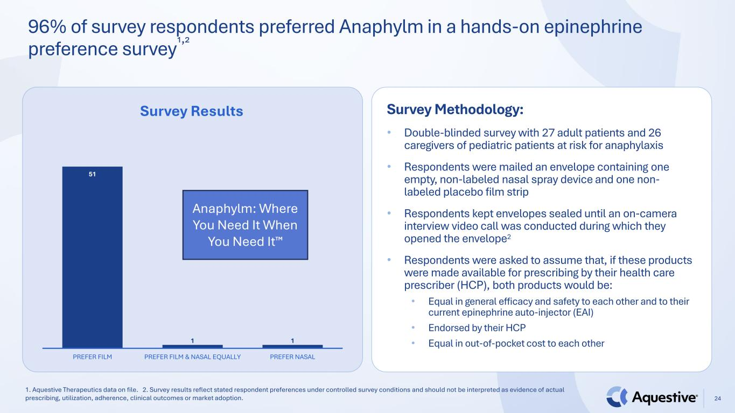
96% of survey respondents preferred Anaphylm in a hands-on epinephrine preference survey¹,² 1. Aquestive Therapeutics data on file. 2. Survey results reflect stated respondent preferences under controlled survey conditions and should not be interpreted as evidence of actual prescribing, utilization, adherence, clinical outcomes or market adoption. 24 Survey Methodology: • Double-blinded survey with 27 adult patients and 26 caregivers of pediatric patients at risk for anaphylaxis • Respondents were mailed an envelope containing one empty, non-labeled nasal spray device and one non- labeled placebo film strip • Respondents kept envelopes sealed until an on-camera interview video call was conducted during which they opened the envelope2 • Respondents were asked to assume that, if these products were made available for prescribing by their health care prescriber (HCP), both products would be: • Equal in general efficacy and safety to each other and to their current epinephrine auto-injector (EAI) • Endorsed by their HCP • Equal in out-of-pocket cost to each other 51 1 1 PREFER FILM PREFER FILM & NASAL EQUALLY PREFER NASAL Survey Results Anaphylm: Where You Need It When You Need It

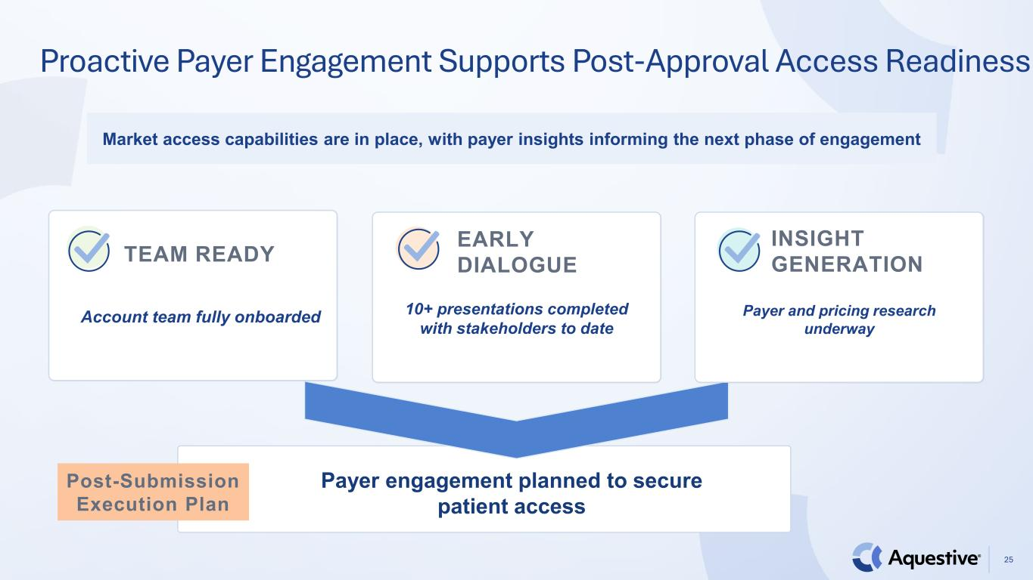
25 Market access capabilities are in place, with payer insights informing the next phase of engagement Proactive Payer Engagement Supports Post-Approval Access Readiness TEAM READY Account team fully onboarded EARLY DIALOGUE 10+ presentations completed with stakeholders to date INSIGHT GENERATION Payer and pricing research underway Post-Submission Execution Plan Payer engagement planned to secure patient access


A Promising Pipeline: AQST-108 (epinephrine) Topical Gel 26

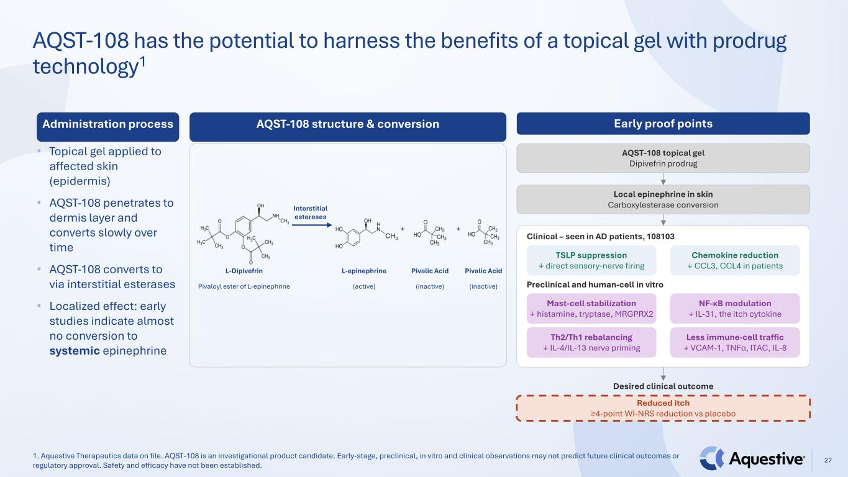
27 AQST-108 has the potential to harness the benefits of a topical gel with prodrug technology1 Administration process • Topical gel applied to affected skin (epidermis) • AQST-108 penetrates to dermis layer and converts slowly over time • AQST-108 converts to via interstitial esterases • Localized effect: early studies indicate almost no conversion to systemic epinephrine Early proof points AQST-108 topical gel Dipivefrin prodrug Local epinephrine in skin Carboxylesterase conversion Clinical – seen in AD patients, 108103 TSLP suppression ↓ direct sensory-nerve firing Chemokine reduction ↓ CCL3, CCL4 in patients Preclinical and human-cell in vitro Mast-cell stabilization ↓ histamine, tryptase, MRGPRX2 NF-κB modulation ↓ IL-31, the itch cytokine Th2/Th1 rebalancing ↓ IL-4/IL-13 nerve priming Less immune-cell traffic ↓ VCAM-1, TNFα, ITAC, IL-8 Desired clinical outcome Reduced itch ≥4-point WI-NRS reduction vs placebo AQST-108 structure & conversion L-Dipivefrin Pivaloyl ester of L-epinephrine L-epinephrine (active) Pivalic Acid (inactive) Pivalic Acid (inactive) Interstitial esterases 1. Aquestive Therapeutics data on file. AQST-108 is an investigational product candidate. Early-stage, preclinical, in vitro and clinical observations may not predict future clinical outcomes or regulatory approval. Safety and efficacy have not been established.


28 Thank You

